Module 4- WASH in Emergencies

Assignment 4:

*Water Hygiene and Sanitation (WASH)*

BY

Larbi Aït Si Selmi

SUBMITTED IN PARTIAL FULFILMENT OF THE REQUIREMENT FOR THE AWARD OF A DIPLOMA IN WATER SANITATION AND HYGIENE TO STRATEGIA NETHERLANDS

30th April 2019

**Introduction**

It is well known that, at the end of this century, we are experiencing a period of great change characterised by the general recomposition of geostrategic forces, social forms, economic actors and cultural references. The world is being shaken by tremendous technological changes, the persistence of economic disorders and the rise of ecological perils (Ramonet, 1998, p. 67). These upheavals are particularly felt in developing countries who face multiple emergencies and suffer the most of the effects of these changes (especially true during crisis / emergency situations) in a context in which the only certainty is uncertainty. Furthermore, as stated in the Water, Engineering and Development Centre (WEDC) “Emergency Water Sources: Guidelines for selection and treatment” manual, an emergency can be defined as: A natural or human-induced disaster, of slow or sudden onset, which results in a serious disruption of society, causes widespread human suffering and physical loss or damage, and stretches the community’s normal coping mechanisms to breaking point (therefore requiring external assistance for potentially long-lasting periods -although our goal is to ensure communities acquire sufficient means to cope with potential upcoming issues and do not become permanently dependent of multilateral support from agencies-)” (House & Reed, 1997, p.2). In such a context, this fourth assignment will therefore go over elements covered in the three prior assignments, putting an accent on public health issues with a particular focus towards community health (participation, empowerment and management by the communities). Without further ado, the questions covered will be: Briefly describe what is Waste Management? What does “Municipal Solid Waste” (MSW) mean? What are challenges in Waste Management faced by the local authorities in my country (Canada)? What are the advantages and disadvantages of source separation in MSW? What are the challenges faced in disease surveillance? What are five diseases which can be prevented by observing proper sanitation?

1. **What is Waste Management (briefly)?**

According to the 2018 edition of the Sphere Handbook, Solid Waste Management can be defined as “the process of handling and disposing of organic and inorganic solid waste” which involves planning solid Waste Management systems; handling, separating, sorting and processing waste at source; transferring to a collection point; transporting and final disposal, reuse, re­purposing or recycling (Sphere Association, 2018, p. 126). Furthermore, this standard is strongly linked to the Vector Control standard as inappropriate disposal of organic waste increases the risk of disease-bearing vectors breeding (rats, flies, mosquitoes, etc.), increases the risk of water contamination (e.g. surface water pollution, etc.) and creates a depressing and ugly environment which could discourage community efforts to improve other aspects of environmental health (open defecation, etc.) (Strategia Netherlands, 2018, -*chap 2*-* p. 5). Waste Management objectives should therefore primarily be observed (short term) through the scope of the entire cycle of material use (production, distribution, consumption, collection and disposal) and in the long term through waste reduction strategies (minimisation of waste generation) and recycling/reuse maximisation (Strategia Netherlands, 2018, p. 96). Waste Management therefore involves a cyclical process (objective setting, long-term plan establishment, programming, budgeting, implementation, operations and maintenance, monitoring and evaluation, cost control, revision of the prior mentioned objectives and plans) and service provision task which is to be insured by the government with the (potential/if needed) support of partners and/or private enterprises and (optimally) the inclusion of users of the services (in order to promote community participation and management in the process) (Strategia Netherlands, 2018, p. 94).

1. **What does “Municipal Solid Waste” (MSW) mean?**

First and foremost, due to the urban/rural environmental sanitation problems which result from poor waste management in emergency settings (contamination of water supplies and the environment in general, proliferation of disease-bearing vectors -insects and rodents, etc.-) (United Nations Children’s Fund, 1986, p.91), it goes without saying that one cannot put in place a fully functional water, Hygiene and Sanitation (WASH) intervention without ensuring an adequate Municipal Solid Waste Management (MSWM) System (especially true in low-income groups), defined here as “the collection, transfer, treatment, recycling, resource recovery and disposal of solid waste in urban areas” (Strategia Netherlands, 2018, p. 95). Moreover, in order to correctly address the MSWM issue, it is central to define what is Municipal Solid Waste. According to the United States Environmental Protection Agency (EPA), the term “Municipal Waste” implies a number of “regular” wastes consisting of everyday items (product packaging, grass clippings, furniture, clothing, bottles and cans, food scraps, newspapers, appliances, consumer electronics, and batteries) (EPA, 2018, p. 1). Strategia Netherland’s Manual goes further in defining “Municipal Solid Waste” by including “Refuse from households, non-hazardous solid waste from industrial, commercial and institutional establishments (including hospitals- e.g. needles, biohazards, etc.), market waste, yard waste and street sweepings (etc.)” (Strategia Netherlands, 2018, p. 94).

1. **What are challenges in Waste Management faced by the local authorities in my country (Canada)?**

The Waste Management cyclical process (objective setting, long-term plan establishment, programming, budgeting, implementation, operations and maintenance, monitoring and evaluation, cost control, revision of the prior mentioned objectives and plans, etc.) (Strategia Netherlands, 2018, p. 94), although particularly problematic in developing countries due the (potential) absence of service provision by the government (leading to poor Waste Management systems, due to low budgets/priorities regarding the issue, multiple emergency settings, internal wars, etc.), touches an increasing number of “developed countries” all around the word. In fact, the 21st century could be defined, with regards to its multiple environmental issues (temperatures rising, environmental pollution, animal/vegetal species extinction, desertification, etc.) as “the century of recognition (finally) of the environmental problem” since an increasing number of countries and international organisations/entities not only recognise the environmental emergency but also “combine their forces” in order to address it’s problematics (e.g. Paris Climate Agreement, Kyoto Protocol, UNEP, OCDE, etc.). Canada is one of these countries which got involved, externally (above mentioned international treaties and agreements ratification) and internally (e.g. the “Environmental protection act”, etc.) through regulations which can be advanced by all three levels of government (federal, provincial and municipal levels – although waste management and recycling are mostly regulated at a provincial level) (R., How Waste is Regulated in Ontario, 2019).

Unfortunately, and as advanced by the OCDE, Canada has a poor record on waste according to recent international ranking of OCDE countries by the Conference Board of Canada (Canada is 17th out of 17) (T., Municipal Waste Generation, 2019, p.1) as this bar graph demonstrates:

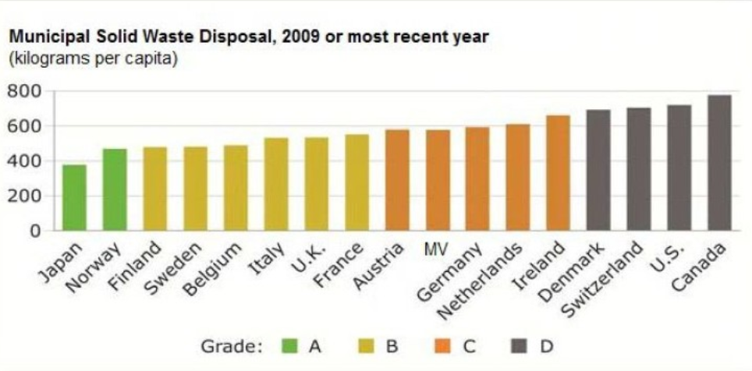

(G., GLOBE, 2014)

Furthermore, and as advanced by the “Giroux Environmental Consulting” firm in its report for the Canadian Council of Ministers of Environment on the issue of *State of Waste Management in Canada*, the amount of non-hazardous total waste (residential and non-residential) sent to disposal in 2010 was equal to over 25 million tonnes (Giroux, L., D., R., & E., 2014, p.E-1) which is poorly managed (most municipal waste goes to landfills and small amounts are incinerated) causing increasing environmental concerns (risk of groundwater and surface water contamination) (T., Municipal Waste Generation, 2019) and increasingly and abnormally high management costs as well as missed opportunities to extract value from materials in the waste stream (Giroux, L., D., R., & E., 2014, p.E-1).

This bar graph perfectly demonstrates the high costs associated with this issue and the poor amount of budgets used in recycling/organic processing facilities versus disposal facilities (often inadequate):

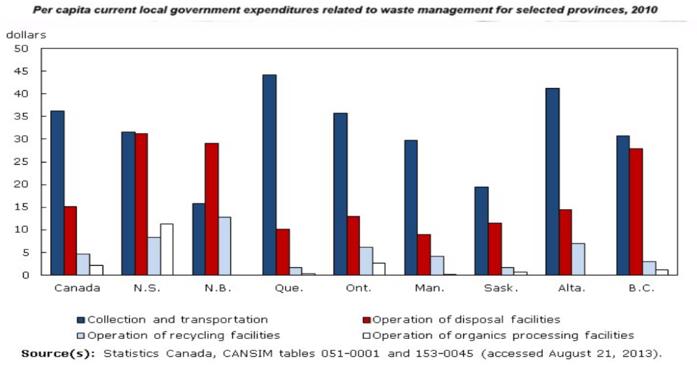

(G., GLOBE, 2014)

1. **What are the advantages and disadvantages of source separation in MSW?**

Prior to stating the advantages and disadvantages which may result from source separation in Municipal Solid Waste (MSW), it is central to clearly identify what such a process implies. According to the case study of Changsha (China) regarding “Source separation of municipal solid waste: The effects of different separation methods and citizens inclination”, source separation of MSW can be defined as: “The separation of MSW into several categories at the generation source according to the different characteristics of each material before further treatment.” (Chen, et al., 2016, Abstract). Moreover, it seems crucial to advance the importance of ensuring proper Municipal Solid Waste Management (by the communities themselves, local authorities, private sector and potentially humanitarian agencies -e.g. NGOs, International Organizations, etc.) due to the fact that poor/improper MSWM systems are directly linked to conventional mixed collection and transportation systems (where these entities even exist) which may cause environmental problems originating from the uncontrolled release of methane/leachate or lead to public health problems (vector proliferation, etc.) (Chen, et al., 2016, Abstract). Furthermore, a central advantage of source separation is a potential increase in the practice of the “3R” principal (e.g. Reduce, Recycle and Reuse) which results in enhanced waste recycling and the reduction of waste rather than burning/burring practices which harbour environmental sanitation dangers (therefore potentially increasing public health related issues) (Chen, et al., 2016, Abstract). Additionally, another potentially positive aspect of source separation in MSW is that it may lead to increased decentralisation of authority by the government on issues related to MSWM, which, in turn will allow local authorities to focus on their “main responsibilities” (areas of legislation, definition of standards, environmental monitoring and support to municipalities). Decentralisation will also allow government officials to delegate their competencies regarding SWM to municipalities, their communities (therefore inducing increased community participation, developing ownership and promoting active involvement) and the private sector (allowing for job creation, cost reduction of services, potentially heightened performance/efficiency - “do more with less”- and accountability) (Strategia Netherland, 2018, p.111). These strategies will promote increased attitude changes regarding use, handling, reduction/minimisation/separation; more efficient, cost diminished operations/collection; and increased productivity and development of the local economy (Strategia Netherland, 2018, p.117). Unfortunately, a number of issues may also arise from separation of MSW, to name a few: increased stress/burden on informal sector waste workers (social marginalisation and fragmentation, poor access to work security equipment due low budgets/access, lower numbers/access to jobs and lower salaries, etc.) (Strategia Netherland, 2018, p.117); risk of poor appropriateness of investment decisions (“white elephants”-e.g. “inflated” operating expenses) due to lack of financial analysis or procedures (not conducted appropriately/biased); and potentially inappropriate choice of technology/technological systems in terms of primary collection, storage, transport, treatment and final disposal (poorly suited for the operational requirements of the area/country) (Strategia Netherland, 2018, p.123) .

1. **What are the challenges faced in disease surveillance?**

According to The Sphere Project Handbook: “Humanitarian Charter and Minimum Standards in Disaster Response”, a number of strategies should be implemented in order to control outbreaks of potential communicable diseases: Attacking the source (reduction of potential infection sources to prevent disease spreading between community members/between communities – prompt diagnosis and treatment; potential isolation of infected community members; animal reservoir control, etc.), susceptible group protection (immunisation, “better” nutrition, etc.) and transmission interruption (goal: minimising the spread of diseases through environmental, personal hygiene, health education, vector control, disinfection and sterilisation) (Walker, P., 1998, p.25). Unfortunately, the chaotic nature of emergencies complicates the implementation of these strategies as it constitutes severe traumas for the affected populations and their environments: it increases their vulnerability (physical, organisational and psychological), weakens the community’s capacity to handle the effects of the crisis (capacity to cope with the problems created by the phenomenon), increases their risk of being exposed/in contact with pathogens/vectors (etc.) and creates a favourable environment for illnesses to spread (Perrin, P., 1996, p.343). Due to this reality, and as advanced by the Strategia Netherlands Manual, four central environmental factors (everything that surrounds the pathogen in its transmission from host to a susceptible animal/person) – controllable or not- should be considered when addressing potential disease surveillance challenges, namely: The climate, the landscape, the human surroundings and the human behaviour. The issue of the *climate* is characterised by the seasonal changes which play a central role in disease transmission as it increases the presence of vectors and intermediate hosts (e.g. to name a few: Mosquito-borne infections – Malaria/yellow fever -, diarrhoeal diseases correlate with the rainy season; Cold temperatures increase crowding which correlates with a number of communicable diseases due to poor personal hygiene, etc.) (Strategia Netherlands, 2018, p.26). The issue of the *landscape* – natural or man-made - (deserts, rivers, jungle, artificial water reservoirs and deforested areas) can strongly increase the risk of disease transmission due to the fact that it is hardly modifiable (e.g. WES Specialists) and can potentially constitute favourable habitats/reproduction sites for vectors and intermediate hosts. The issue of the *human surroundings* differs from the landscape due to the fact that it is easily modifiable and its link to specific circumstances (e.g. specific occupation/work, gender, etc.); while adequate adaptations (SWM, Vector control measures through environmental modification/sanitation, etc.) may prevent disease spreading, improper human surrounding modifications, as mentioned above can encourage disease transmission since individuals in the emergency may not have the time, space, understanding, motivation and means to do them adequately (Strategia Netherlands, 2018, p.27). The *human behaviour* issue is considered to be the most important factor in reducing WES related diseases (through hygiene improvements and behavioural changes) but is extremely complex to address due to its influences from subjective factors such as: culture (religion, attitudes, traditional beliefs, etc.), social position (gender, age, cast, etc.), availability of means (money, time, material, energy, etc.) and politics (Strategia Netherlands, 2018, p.27). Furthermore, emergencies are often characterised by population displacements which can hinder a population's immunity/herd immunity: influx of non-immune individuals/infected individuals (to which the community is not immune) causing disease transmission and potential epidemics/endemics, births and loss of immunity (time-related or HIV infections, etc.) (Strategia Netherlands, 2018, p. 33), births, etc.; In this context, disease surveillance can often represent a real struggle for local authorities and NGOs, health professionals and their partners (potentially – extraterritorial NGOs, International Organizations, etc.);

1. **What are five diseases which can be prevented by observing proper sanitation?**

First and foremost, I believe it is absolutely central to remind the importance of community participation. As advanced by the IFRC’s Handbook on War and Public Health, readily made systems/strategies without community involvement are doomed to failure due to lack of interest, insufficient motivation to ensure maintenance and in the short term, lack of use. Communities (men and women) should therefore be involved at all stages of the project from its conception – e.g. the selection of the source- to its technical setups (pump, distribution systems, health/hygiene/sanitation education strategies, etc.) with a particular accent on implementation (Perrin, P. 1996, p.102). Moreover, one also needs to define what is sanitation in order to adequately cover the diseases which can be prevented through it: Anything associated with excreta related to people; it implies the structures used to properly deal with excreta (e.g. latrines); adequate material access for the proper use of these structures (e.g. water, etc.); and behavioural/attitude modification in relation to excreta and sanitation structures (cessation of harmful habits such as open defecation, and post defecation handwashing -strongly associated with poor environmental sanitation and leading to diarrhoeal diseases, vector proliferation, etc.-) and access to water of sufficient quality (not infected with excreta/chemically infected, etc.) (Strategia Netherlands, 2018, p.66). Now addressing the particular aspect of disease prevention through the lens of environmental sanitation, an important element to address will be adequate garbage control and the accumulation of waste/stagnant water (Assisting in emergencies, p.92) as they are considered to be ideal breeding grounds for various communicable disease vectors as for example insects (e.g. mosquitoes -*potentially transmit malaria, dengue, yellow fever, etc.* flies *-strongly linked to spread of diarrhoeal diseases as diarrhoea and cholera due to food/eye/hand/etc. contamination-*) and rodents (e.g. rats *-favour the transmission of leptospirosis, etc.-*) (Perrin, P., 1996, p.108), which are directly associated with important numbers of deaths amongst disaster affected populations, when not dealt with appropriately (due to the nature of the emergency situations which tends to promote overcrowding, lack of water, poor hygiene and sanitation that directly favor the spread of these groups of diseases) (Sphere Project, 1998, p.26). Strategies to control the potential spread of these illnesses should therefore imply adequate garbage collection at household level, transport and disposal of waste at a preselected dumping area (with a particular focus on sufficient distance from households and strict hygiene measures- to avoid proliferation of vectors and groundwater contamination, etc.) and combined modes of intervention: physical interventions (drainage of rain water and waste water, prevention of overcrowding, use of traps for specific vectors – rats/flies- and the potential use of mosquito nets) as well as chemical interventions (insecticide/larvicides/repellents) to reduce the proliferation and opportunities for contact between vectors and healthy humans (Perrin, P., 1996, p.110). Table 6.3 of Strategia Netherland’s manual regarding Water Environment and Sanitation perfectly demonstrates the type of vector and excreta related diseases and the reduction of their occurrence with regards to improved sanitation (structures, hand-washing post defecation, etc.: control of soil transmitted helminths -entrance by penetration through the skin/ingestion, diarrhoeal diseases, etc.) (Strategia Netherlands, 2018, p. 24)

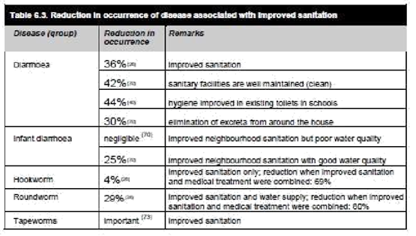

(Strategia Netherlands, 2018, p.70).

**Conclusion**

In conclusion, this paper, while still concentrating on Water, Hygiene and Sanitation (WASH) aspects of disaster response, focuses primarily on promoting environmental sanitation in emergency settings in both rural and urban areas. Interestingly enough, it also brings our attention to the worldwide environmental crisis regarding poor Waste Management and the poor application of strategies as “3 Rs”: Waste Recycling, Reuse and most importantly Waste Reduction. Furthermore, while still promoting the central strategy of Community Participation and Community Management (which is to be adopted in any field intervention) in Waste Management and disease prevention (e.g. through proper sanitation, etc.), this paper also promotes governmental decentralisation strategies for Municipal Solid Waste and its Management (MSW and MSWM). These strategies aim to allow local authorities and government officials to concentrate their efforts on their “main responsibilities” (areas of legislation, definition of standards, environmental monitoring and support to municipalities), the creation of legislation (etc.) regarding the protection of environmental health, the quality promotion of the rural/urban environments, the support of the efficiency/productivity of the economy and the generation employment/income through coordination strategies with the private sector, local health professionals, NGOs and International Partners/Agencies (NGOs, International Organizations, etc.). Furthermore, it is also a focus on various types of illnesses which can be controlled/eliminated through proper environmental sanitation (vector control strategies, waste/excreta management, etc.).

**Bibliography:**

* Chen, H., Yang, Y., Jiang, W., Song, M., Wang, Y., & Xiang, T. (2016, September 14). Source separation of municipal solid waste: The effects of different separation methods and citizens' inclination-case study of Changsha, China. Retrieved April 27, 2019, from <https://www.tandfonline.com/doi/full/10.1080/10962247.2016.1222317>
* EPA's Report on the Environment (ROE). (2018, September 18). Retrieved April 26, 2019, from <https://www.epa.gov/report-environment>
* G. (2014, September 13). Waste Management in Canada – Problems and Opportunities - GLOBE-Net. Retrieved April 27, 2019, from <http://globe-net.com/waste-management-canada-problems-opportunities/>
* Giroux, L., D., R., & E. (2014). State of Waste Management in Canada - CCME. Retrieved April 27, 2019, from [https://www.ccme.ca/files/Resources/waste/wst_mgmt/State_Waste_Mgmt_in_Canada April 2015 revised.pdf](https://www.ccme.ca/files/Resources/waste/wst_mgmt/State_Waste_Mgmt_in_Canada%20April%202015%20revised.pdf)
* House, S., & Reed, B. (1997). Emergency water sources: Guidelines for selection and treatment. Loughborough, England: Water, Engineering and Development Centre, Loughborough University.
* Perrin, P., Dr. (1996). Handbook on war and public health (M. Grenzeback, Trans.). Geneva: International Committee of the Red Cross.
* Ramonet, I. (1998). Géopolitique du chaos. Paris: Galilée.
* R. (2019). How Waste is Regulated in Ontario. Retrieved April 26, 2019, from <https://rco.on.ca/resources/how-waste-is-regulated/>
* Sphere Association (2018). The Sphere Handbook: Humanitarian Charter and Minimum Standards in Humanitarian Response (4th ed.). Geneva, Switzerland, 2018.
* Strategia Netherlands (2018) Water, Sanitation and Hygiene Manual. Chap.2. Princes Beatrixloan 58, The Hague, Netherlands.
* Strategia Netherlands (2018) Water, Sanitation and Hygiene Manual. Chap.4. Princes Beatrixloan 58, The Hague, Netherlands.
* T. (2019). Municipal Waste Generation. Retrieved April 27, 2019, from <https://www.conferenceboard.ca/hcp/details/environment/municipal-waste-generation.aspx?AspxAutoDetectCookieSupport=1>
* United Nation Children’s Fund (1986) Assisting in emergencies: A resource handbook for UNICEF field staff. New York. NY.
* Walker, P. (1998). Humanitarian Charter and Minimum Standards in Disaster Response (1st ed.). Geneva, Switzerland, The Sphere Project.